**Analytics for Flare Event Prediction**

**Status Report**

1 Introduction 2

2 FHR Flare Data 3

2.1 Initial analysis with 114 tags 3

2.1.1 PCA 4

2.1.2 Cross-Correlation 4

2.1.3 PPLC and BOV 4

2.1.4 PCA, Cross-Correlation, and BOV Intersection 5

2.1.5 Rolling Averages and Standard Deviations 5

2.1.6 Frequency Analysis 6

2.2 Analsyis with 130 tags 9

References 9

# Introduction

This document describes the current status of a project using analytics to predict flare events at the Flint Hills Refinery (FHR) in Corpus Christi, Texas. The objective is to provide at least 15 minutes early warning to operations that a flare event is likely to occur so that they can take action to avoid it if possible.

FHR has installed a flare gas recovery compressor (FGRC) that has successfully eliminated many releases of chemicals to the atmosphere via the flare tower. The recovered compressed gas is sent to the refinery fuel gas system. Currently a flare event occurs when the FGRC cannot compress all of the material it receives and the excess gas goes to the flare tower where it is burned prior to being released to the atmosphere. During a recent year 14 such events occurred. FHR desires to eliminate as many of these events as possible.

A dataset with 130 process tags for one year at one minute resolution was received from FHR. The tags were flows, temperatures, and pressures associated with equipment connected to the flare system. The tags were collected from many of the 61 process units utilizing the flare system. This dataset contained 14 flare events. An additional year of data was obtained along with one day of one minute data associated with a flare event.

Several techniques were tried to develop predictive models that could give early warning of flare events. These included:

* Correlation analysis
* Principal components analysis (PCA)
* Frequency analysis
* PCA on the results of sliding window frequency analysis
* Anomaly detection

The most promising techniques were PCA and sliding window frequency analysis with PCA. Anomaly detection deserves more investigation.

FHR has stated interest in conducting a field trial. The next steps required to get to the field trial are:

1. Finalize analytic method or set of methods to use online.
2. Create an online implementation using OSI PI as the source and destination of real-time data and model predictions.
3. Test and deploy

It would also be desirable to obtain data for tags that are “deeper” into each process unit. For example rather than only temperatures and pressures from an overhead receiver that is connected to the flare system it might be useful to get tags for measurements within a distillation column.

# FHR Flare Data

The data used in this project thus far can be divided into 3 groups:

1. 114 tags (pressures, temperatures, flows) for a one year period at one minute resolution.
2. 130 tags(added tags around the FGRC) for the same time and resolution as above
3. One day of data for a specific flare event not contained in sets 1 or 2 above.

## Initial analysis with 114 tags

A data set from the Flint Hills refinery containing 114 tags with 1 year of 1 minute samples was analyzed. This data set contained 4 “official” flare events defined as occurring when Tag-10P1019 > 0.97 \* Tag-10L1019. The 114 tags were identified as being associated with the flare events and consisted of approximately 100 pressures, 6 flows, 7 controller outputs, and the 10L1019 level. The level 10LP1019 represents the water-leg level in the flare. The pressures were described as being pressures on the tower reflux accumulators which have connections to the flare system. The exact location and configuration is not known but the 2 leading digits on the Tag indicate the refinery unit number. For example 10P1019 is the pressure on the flare itself where the flare unit number is 10.

The objective of the analysis was to identify leading indicators of the flare events. Several techniques were used including:

1. PCA
2. Cross-Correlation
3. BOV (Best Operating Values) from PPLC
4. Rolling averages and standard deviations
5. Frequency analysis

Findings from using these techniques are discussed below.

In summary:

1. The low number (4) of flare events is small for applying statistical techniques. This is made worse by the apparent near-independence of the 4 events. That is the intersection of tags that seemed to be related to each flare event was small.
2. There was no single analysis technique or unique set of tags that could serve as leading indicators for all flare events. Some tags were identified as being important in 2 or 3 flare events.
3. PCA analysis using Q and T2 statistics gave approximately 2 minutes of lead time for 2 out of 4 flare events.
4. More investigation of the rolling mean and standard deviation should be undertaken with a systematic evaluation of many tags for each flare event.
5. Some tags such as the scaled sum of all flow variables had periodic behavior that was sometimes disrupted in the vicinity of a flare event.
6. Significant work was required to visualize the large amount of data available. Some specific features created and used were:
   1. Plot any reasonable set of tags along with event data such as pointers to the flare events
   2. Zoom in and out of the data
   3. Generate multiple plots on the same page in various layouts and grids
   4. Use 2 y-axis scales
   5. Plot raw tag values along with calculated values
   6. Useful but not implemented would be plotting multiple lines for the same tag but each line from a different time window.
7. Even though the dataset was large more data is needed including tags from the compressor system on the flare line and also “upstream” data for each unit with a pressure tag or flow tag.
8. The large number of plots and data analysis that can be generated requires:
   1. Discipline in keeping track of plots and results
   2. Features in future Big Data Studio that assist the user in keeping track of these things.

### PCA

PCA analysis showed that 13 PC’s captured >50% of total variance. The T2 and Q statistics spiked for each flare event but only provide 1 or 2 minutes of lead time after deviating from 2-sigma limits. The complete report is located at: "$/Hawk/Research/Big Data Analytics/Projects/FlintHillsFlareProject1/Docs/PCA".

The results are compared with cross-correlation and BOV below.

### Cross-Correlation

Cross-correlation of all tags with 10L1019 and 10P1019 (the flare level and pressure respectively) were calculated using the R statistical analysis package. The “pearsonr” function in the Python scipy.stats library was used. See common.py and correlation.py in FlintHillsFlareProject1.git.

No obvious leading indicators were found however this should be revisited with some of the better plotting routines now available which allow for better zooming on large amounts of data. Also because the cross-correlation looks at time lags between two variables many false signals would be possible due to the frequent spikes in much of the data.

The results are compared with PCA below.

### PPLC and BOV

Software from PPLC was used to find the BOV or Best Operating Values and deviations from BOV.

The results are compared with PCA and cross-correlation below.

### PCA, Cross-Correlation, and BOV Intersection

The top 10 contributors to PCA Q and T2 statistics (PCA tags) were compared with the tags whose absolute-value correlation coefficients were > 0.5 (CorrCoef Tags) and also the tags found by PPLC (PPLC tags.) or BOV (Best Operating Values)

Interesting observations were that the PCA tags associated with a given flare event were often for different pressures than the CorrCoef tags. The PPLC tags showed up or coincided with PCA tags and were also found in the list of PCA tags for flare events where the PPLC method did not identify them.

The spreadsheet "$/Hawk/Research/Big Data Analytics/Projects/FlintHillsFlareProject1/Docs/FlintHillsFlares compare PCA varsF with Correlated vars.xlsx".

For the PCA and cross-correlation analysis there were 2 or fewer intersecting tags (found by both methods, not counting 10L1019 and 10P1019 tags).

As might be expected PPLC (BOV) tags were most likely to appear in the list of important PCA Q tags. The intersections were small with 2 being the maximum found and that was in flare event 3.

### Rolling Averages and Standard Deviations

The Python Pandas library functions “rolling\_mean” and “rolling\_std” were used to calculate the rolling mean and standard deviation for different size windows. These values appear to show nice “signals” but they did not appear to provide leading indicator for actual flare events.

The following chart shows the rolling mean and standard deviation for tag 40P146 with windows of 1000 and 5000 one-minute samples. The green arrows represent the 4 actual flare events and other “near” events determined by changing the constant in the flare calculation from 0.97 to 0.90.

The large signals in early April coincided with “near” flare events, not actual. The spikes near the second green arrow from the left do coincide with an actual flare event. More investigation should be done as tag 40P146 was not associated with all of the flare events.

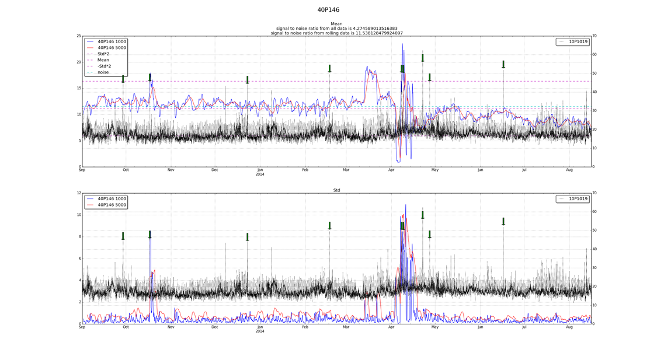

### Frequency Analysis

Because each flare event appeared to be associated with a nearly unique set of tags, we scaled (0 to 1) the groups of pressure, flow, and control output (valve) tags and summed each group. The idea was that we hoped to see a change in the summed values associated with a flare not caring initially which specific tag or tags were the cause. For the flow sum there was an obvious periodic component that appeared to break down or change prior to 2 of the flares. An example is shown in the chart below.

The pressure and controller output sums showed periodic behavior but no obvious change near flare events or anywhere for that matter.

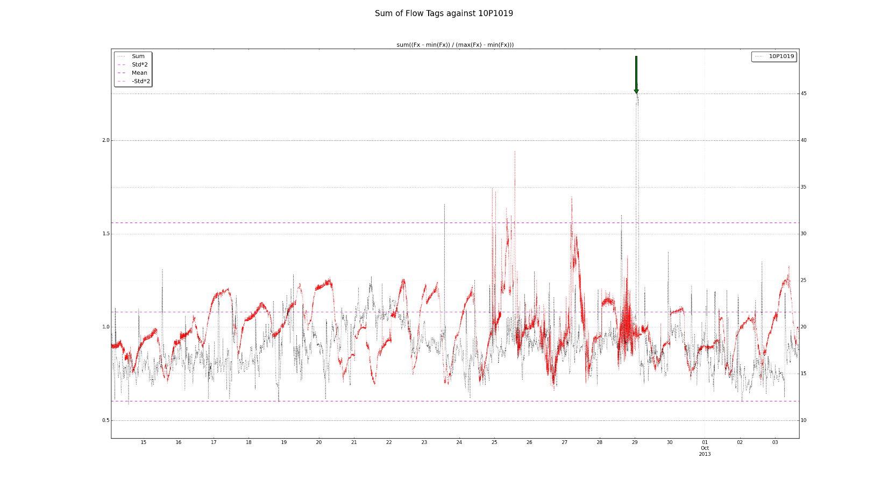

Flow behavior during what is considered “normal” operation is shown in the next plot. The periodic behavior may be associated with daily heating and cooling cycles.

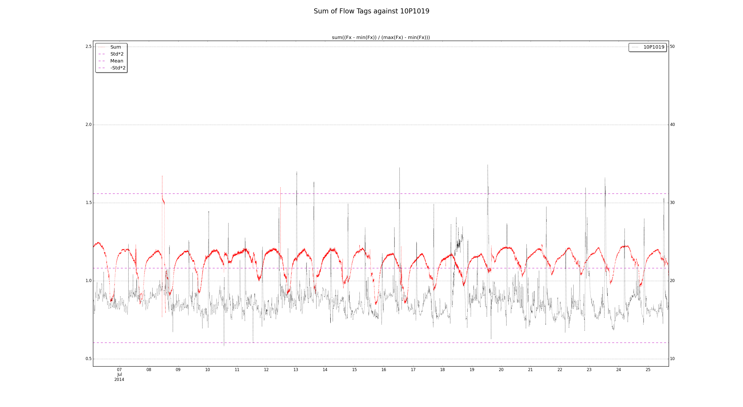Because of the periodic nature of the flow signal frequency analysis was undertaken using the Fast Fourier Transform code in the Python scipy library fft function. This was implemented as a “rolling” fft with a window of approximately 5000 samples. For each window which moved forward by one sample at each iteration the dominant frequencies and their magnitude were obtained and saved in the dataframe with the original data.

The following plot shows the output for one tag. The top 4 charts show how the dominant frequencies change throughout the course of the year. The bottom plot shows the 10P1019 tag along with the flare events (actual and near-flare events.)

While there was a visual indication in the raw data for 2 of the 4 flares that the frequency characteristics changed prior to an actual flare event the current rolling fft analysis did not provide a signal for that. Additional work could be done here as the technique seems promising.

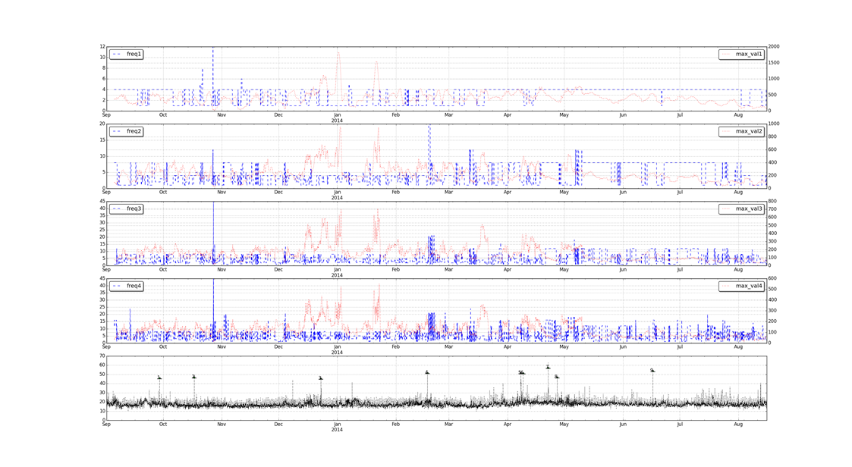

## Analsyis with 130 tags

Subsequent to working with the data set with 114 tags, more tags were obtained for the same time period bringing the total to 130. The additional tags were associated with the FGRC. The main data set used consisted of 130 tags from a one year period at one minute resolution. Also, additional flare events identified by the FHR environmental department were identified. This information came in form of written notes that identified the day of the event. The exact time could then be found by looking at the ration of 10P1019 to 10L1019. Values greater than 0.7 rather than .97 indicated flare events. Thirteen flare events were identified this way including the original four events.

# nhb1_exfat:project_data:flinthills:bokeh_all_flares_0.90.png

### Frequency and Prinipal Components Analysis

Based on the work with the original data set the rolling FFT was used to analyze the entire data set. Approximately 7 of the 13 flare events could be identified with this technique.

In the following example shown in Figures 6 and 7 two flare events occurred in an approximately 1 week time period. The power signal of the frequency with the fourth highest power provided what appears to be a good leading indicator of the flare event. The It can be seen that there is also a false positive. The signal shown in Figure 6 was noisy so PCA was performed on the signal. Figure 7 shows the first component which is a much cleaner signal than the raw rolling FFT provides.

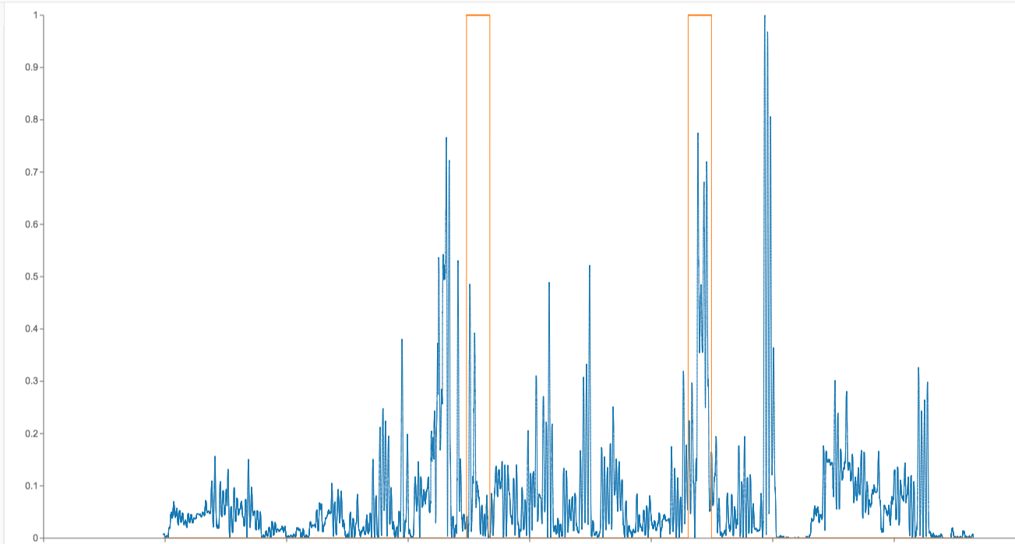

Flare

Power of Freq 4

Figure 6. Rolling FFT frequency power of the fourth highest power. This signal represents 4 cycles per day.

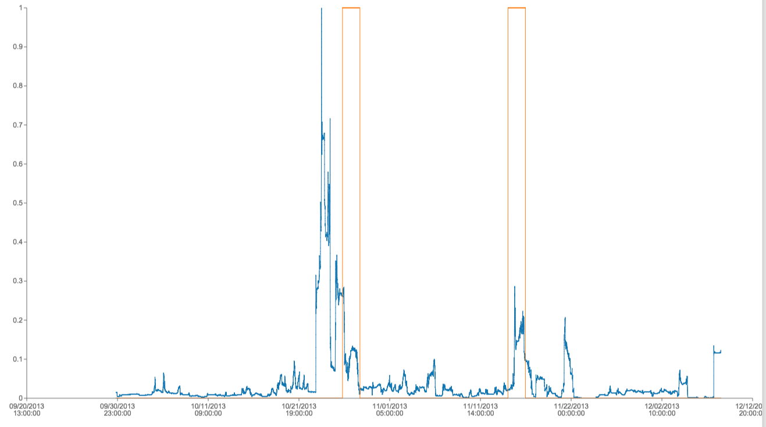

Flare

1st PC

Figure 7. PCA on the rolling FFT signal.

A weighted index consisting of multiple principle component values and T2 and Q statistics might provide a useful composite index. In addition these statistics on the rolling FFT signal might be combined with PCA on the raw tag values to provide a composite index.

## Analysis of the July 3rd flare



Flare Pressure

Indicating Event

Fault Indicator Gives

Early Prediction of Flare

99% Conf. Limit













## Anomaly Detection

Twitter released anomaly detection code written in the R language. A python 2.7 port was created from this. Anomaly detection is a univariate analysis when raw data is used. It is s similar to monitoring the T2 and Q statistics in PCA analysis but it is only univariate. An anomaly occurs when a value is outside a specific confidence interval for the raw value. A confidence interval of 95% or 99% is most commonly used. In addition the twitter code adjusts for trends and seasonality.

Analysis of the individual 130 raw tags did not show any obvious indication of the July 3rd flare event. However, summing all of the anomalies may have provided an indicator. The figure below shows the results for 95% confidence limit anomalies summed together for all tags where an anomaly for one tag has a value of one.

This gives similar results to the PCA analysis and radial basis plot. It should be investigated for the larger data set.

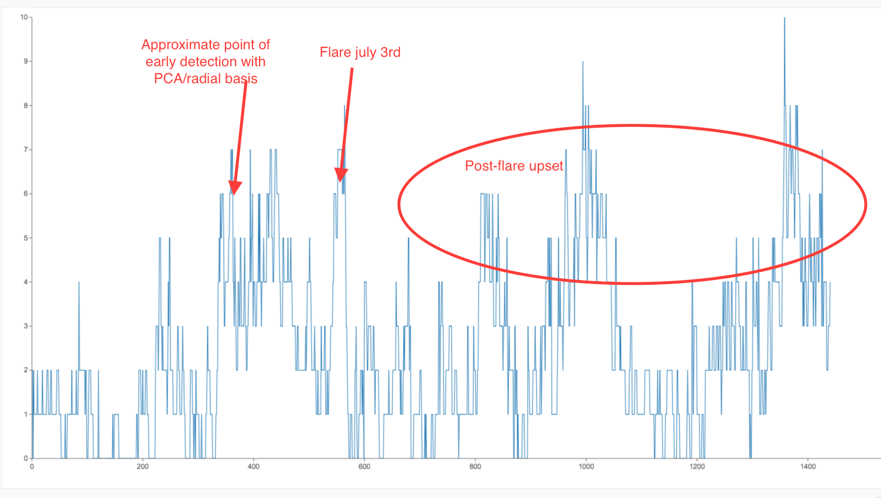

# References

1. **Xxxxx**

All referred documents are in VSS\Research Projects\Analytics